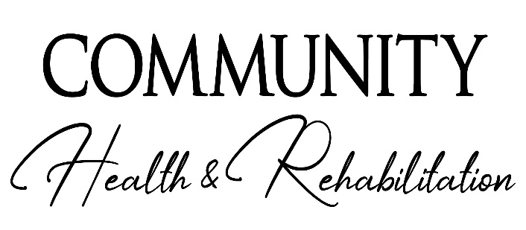 | 3611 Transmitter Road  Panama City, FL 32404  850-588-4643
Community Health & Rehab is an equal opportunity employer. This application will not be used for limiting or excluding any applicant from consideration of employment on a basis prohibited by local, state, and federal laws. Should an applicant need reasonable accommodations in order to complete the application process, he/she should contact a company representative.  Opening This Summer | Please email applications to:  wecare@communityrehab.net
Pre-Employment Application

Position Applied For: _______________________________Date:_________________

Applicant Information
Full Name: |  |  |  | Date:
 | Last | First | M.I.

Address:
 | Street Address | Apartment/Unit #

 | City | State | ZIP Code

Phone: |  | Email
Days Able to Work________________ Shifts :_____________________ Hours per week:_____________________
Date Available: |  | Social Security No.: |  | Desired Salary: | $

Are you a citizen of the United States? | YES | NO | If no, are you authorized to work in the U.S.? | YES | NO

Have you ever worked for this company? | YES | NO | If yes, when?

Have you ever been convicted of a felony? | YES | NO
If yes ,please explain: ________________________________________________________________
Are you Licensed/Certified to work in State of Florida? _______ Yes ______NO

Type: ____________________________ Licensure/Certification #: ________________________________

Are you licensed/certified in another State: Yes_____ No_____ State________________________

Licensure/Certification # and Type/Who Issued: ________________________________________________________

Previous Employment
Company: |  | Phone:
Address: |  | Supervisor:

Job Title: |  | Starting Salary: | $ | Ending Salary: | $

Responsibilities:

From: |  | To: |  | Reason for Leaving:

May we contact your previous supervisor for a reference? | YES | NO

Disclaimer and Signature
I certify that my answers are true and complete to the best of my knowledge.
If this application leads to employment, I understand that false or misleading information in my application or interview may result in my release.
Signature: |  | Date:

Community Rehab/5/7/2020

